mysql链接url更新

异常错误：Loading class `**com.mysql.jdbc.Driver'**. This is deprecated. The new driver class is `**com.mysql.cj.jdbc.Driver'**. The driver is automatically registered via the SPI and manual loading of the driver class is generally unnecessary.

这个问题 是在我整合项目过程中出现的，用了**最新的mysql 连接驱动。**

以前版本的jdbc.properties

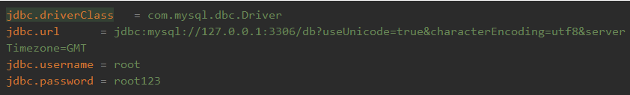

现在按照最新官方提示支持将com.mysql.jdbc.Driver 改为 **com.mysql.cj.jdbc.Driver**

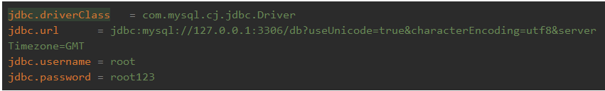

1. jdbc.url=jdbc:mysql:///test?characterEncoding=utf8&useUnicode=true&useSSL=false&serverTimezone=UTC

新版驱动url默认地址为**127.0.0.1:3306**，所以访问本机mysql数据库地址可以用 **///** 表示。

*#db.driverclass=com.mysql.jdbc.Driver***db.driverclass**=**com.mysql.cj.jdbc.Driver***#db.url=jdbc:mysql://127.0.0.1:3306/student?characterEncoding=utf-8***db.username**=**root  
db.url**=**jdbc:mysql://127.0.0.1:3306/student?useUnicode=true&characterEncoding=utf8&serverTimezone=GMT  
db.password**=**zhao12  
db.port**=**3306**

<**properties resource="WEB-INF/mybatis-config/mysql.properties"**>  
</**properties**>

<**environments default="development"**>  
 <**environment id="development"**>  
 <**transactionManager type="JDBC"**></**transactionManager**>  
 <**dataSource type="POOLED"**>  
 <**property name="driver" value="${db.driverclass}"** />  
 <**property name="url" value="${db.url}"** />  
 <**property name="username" value="${db.username}"** />  
 <**property name="password" value="${db.password}"** />  
 </**dataSource**>  
 </**environment**>  
</**environments**>

Mapper对象的获取：

String resource = **"WEB-INF/mybatis-config/mybatis-config.xml"**;  
 InputStream inputStream = Resources.*getResourceAsStream*(resource);  
 SqlSessionFactory sqlSessionFactory = **new** SqlSessionFactoryBuilder().build(inputStream);  
 SqlSession session = sqlSessionFactory.openSession();  
 StudentMapper mapper = session.getMapper(StudentMapper.**class**);  
String name = mapper.getNameById(1);  
 System.***out***.println(**"name = "** + name);

可以通过Spring的bean配置：